IAPETUS
doctoral training partnership

Earth observation for rapid response to large earthquakes and induced landslides

School of Civil Engineering and Geosciences, Newcastle University
In partnership with Department of Geography, Durham University, and Department of Earth Sciences, Durham University

Supervisory Team | - Professor Zhenhong Li, Newcastle University  - Dr Richard Walters, Durham University  - Professor Alexander Densmore, Durham University  - Professor Peter Clarke, Newcastle University

Key Words | Satellite Radar; InSAR; Geohazards; Earthquake modelling; Earthquake induced landslides

Overview
Earthquakes represent a major natural hazard faced by human societies, and their destructive impact is often greatly enhanced by the triggering of landslides during or after the shaking they cause. It is believed that several million deaths, and severe economic damage, will be caused directly by earthquakes during this century due to the continuous growth of megacities, especially across the India-Asia collision.
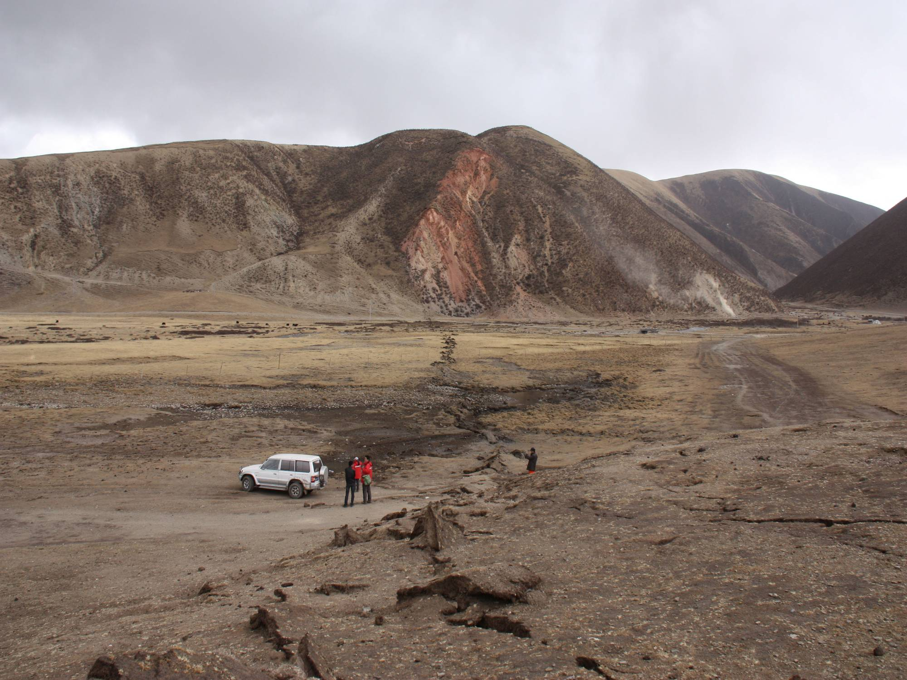
Earthquakes and earthquake-triggered landslides cause severe and persistent damage over large areas and disrupt normal communications. Because survival times for victims can be short in the absence of rescue, it is vital that relief teams be directed to the areas of greatest damage. Using satellite radar (synthetic aperture radar or SAR) data, we can pinpoint probable major damage areas, map surface movements, and determine earthquake mechanisms, but intensive expert interpretation and interaction are currently required.

The ESA Sentinel-1A radar satellite became operational in September 2014 and, together with Sentinel-1B launched in April 2016, is able to provide global coverage every 6 days (Europe and Canada in less than 2 days). Together with other SAR systems, the success of Sentinel-1 has made rapid responses to earthquake hazards possible using satellite radar.

The principal aims of this project are:
- to optimize SAR interferometric processing procedures to rapidly estimate surface movements.
- to adapt the in-house geodetic inversion software (i) to reduce processing times with parallel processing, and (ii) to enable source mechanisms to be automatically derived for large continental earthquakes from deformation data and models of these to be disseminated rapidly via the internet.
- to investigate how the distribution of earthquake-induced landslides depends on earthquake source mechanism.
- to improve seismic hazard assessment.

This study will look at global large continental earthquakes (M_{w} > 6.5) occurring in the next 3 years. Global (or regional) observations are necessary because of the time scales of the processes. The earthquake cycle on any one fault may take hundreds to thousands of years. But on a global basis these events occur frequently, and understanding gained in one location can then be applied more generally.

Methodology
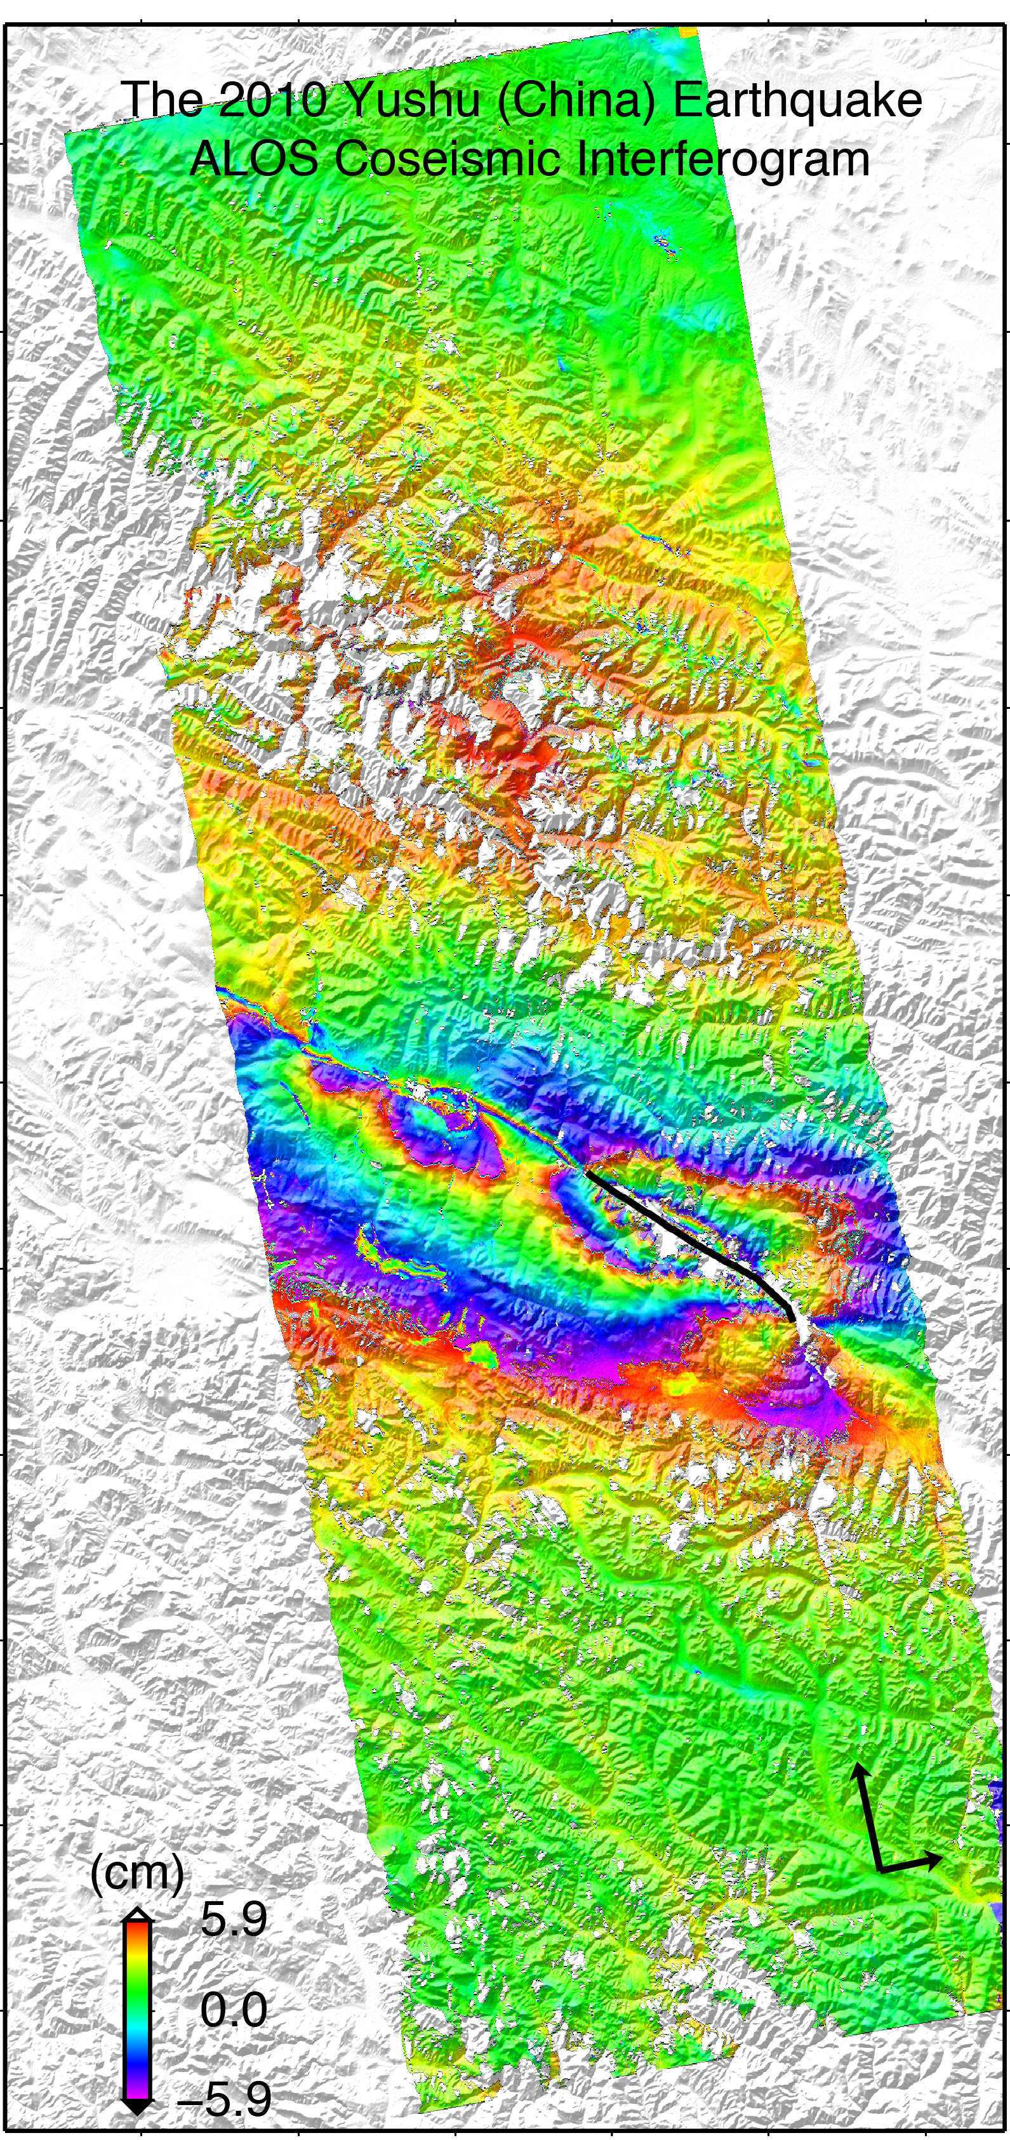
Three SAR-based techniques, i.e. conventional interferometric SAR (InSAR), SAR pixel offset tracking, and multiple aperture InSAR (MAI), will be employed to map surface movements in the satellite line of sight (LOS) and/or the azimuth direction (i.e. along track). The UK Facility for Climate and Environmental Monitoring from Space (CEMS) at the International Space Innovation Centre (ISIC) has a direct pipeline to the Sentinel-1 processing and archive facility, based at Farnborough. Newcastle and Durham Universities are members of the Centre for the Observation and Modelling of Earthquakes, Volcanoes and Tectonics (COMET) and can access the CEMS facility. This makes it possible to process Sentinel-1 SAR data in near-real time.

A two-step inversion strategy is currently employed to determine earthquake mechanisms. This comprises a nonlinear inversion to determine the fault geometry by minimizing the square misfit under the assumption of a uniform slip on a rectangular fault, followed by a linear inversion for estimating the slip distribution on the determined fault plane. The in-house modelling software (PSOKINV) will be modified to enable source mechanisms and Coulomb stress to be automatically determined from deformation data, thus reducing the dependence on expert intervention. The project will also explore ways of determining postseismic and coseismic slips from multiple geodetic datasets (e.g. InSAR, GNSS and levelling) in a single step.

Landslide inventories from new large earthquakes as well as a number of recent events, including the 2008 Wenchuan and 2015 Gorkha events, will be analysed to investigate the links between the distribution of earthquake-induced landslides and the source mechanism.

Timeline
Year 1: Training in space geodesy techniques, in particular the handling of satellite radar data. In parallel, training will be provided on programming skills and the mechanics of earthquakes and earthquake-triggered landslides.

Year 2: Investigation of large continental earthquakes (M_{w} > 6.5), particularly those occurring in south-eastern Asia. Field data will be collected through collaboration and employed to validate satellite results. It is envisioned that the combined work of Years 1 and 2 should lead to at least one publication.

Year 3: Response to new large earthquakes with optimised interferometric processing chain and automatic modelling software. Field work will be carried out to collect field data. This should lead to an additional publication.

Year 4: The final year of the studentship will be focussed on combining the published outputs and associated material into a PhD thesis.

Training & Skills
The student will receive training in space geodesy techniques, in particular the handling of satellite radar data, in modelling the mechanics of earthquakes, and in analysing earthquake-induced landslide inventories. Training in a wide range of generic skills (e.g. presentation skills, paper/thesis writing, and enterprise skills) to prepare the student for life as a PhD student and afterwards is provided by the Faculty of Science, Agriculture and Engineering at Newcastle via the Postgraduate Researcher Development Programme (PGRDP). The student will also benefit from cross-disciplinary training provided as part of IAPETUS. The student will become a member of the Centre for the Observation and Modelling of Earthquakes, Volcanoes and Tectonics (COMET) and s/he will thus benefit from the shared expertise of Geosciences staff in several universities, and will attend regular meetings where the research of these various groups is presented and discussed.
The student will have opportunities to work with other partners in the UK and internationally and they are encouraged to travel to national and international scientific meetings to present results. We aim to see all students publish at least two papers in leading scientific journals during their PhD. Upon completion, the student will be well equipped for a career in academia or in a range of industries.

References & Further Reading
Floyd, M. A., Walters, R. J., Elliott, J. R., Funning, G. J., Svarc, J. L., Murray, J. R., Hooper, A. J., Larsen, Y., Marinkovic, P., Bürgmann, R., Johanson, I. A., and Wright, T. J. (2016). Spatial variations in fault friction related to lithology from rupture and afterslip of the 2014 South Napa, California, earthquake
Geophysical Research Letters, 43, doi:10.1002/2016GL069428
Feng, W., Li, Z., Hoey, T., Zhang, Y., Wang, R., Samsonov, S., Li, Y., Xu, Z. (2014). Patterns and mechanisms of coseismic and postseismic slips of the 2011 M_{w} 7.1 Van (Turkey) earthquake revealed by multi-platform synthetic aperture radar interferometry. Tectonophysics, 632(0), 188-198.
Li, Z., Elliott, J. R., Feng, W., Jackson, J. A., Parsons, B. E., & Walters, R. J. (2011). The 2010 Mw 6.8 Yushu (Qinghai, China) earthquake: Constraints provided by InSAR and body wave seismology. Journal of Geophysical Research - Solid Earth, 116(B10), B10302.
Parker, R.N., Densmore, A.L., Rosser, N.J., de Michele, M., Li, Y., Huang, R., Whadcoat, S. & Petley, D.N. (2011). Mass wasting triggered by the 2008 Wenchuan earthquake is greater than orogenic growth. Nature Geoscience. 4:449-452.

Further Information
Professor Zhenhong Li
Zhenhong.Li@newcastle.ac.uk, 0191 208 5704
http://www.ncl.ac.uk/ceg/role/profile/zhenhongli.html

Annex 1 // Additional Administrative Information

Principal Disciplinary Theme (s)  Tick the relevant box(s). | ☐ Global Environmental Change  ☐ Geodynamics & Earth Resources  ☐ Carbon & Nutrient Cycling  ☒ Hazards, Risk & Resilience  ☐ Biodiversity & Ecosystem Resources

Total of Amount of RTSG Requested: | £ 7000
Justification for RTSG Request:
We request £3000 to cover conference and workshop attendance (one AGU Fall Meeting and one ESA FRINGE workshop).
We request £1000 to purchase high-resolution TerraSAR-X (and/or COSMO-SkyMED) images.
We request £3000 to support field work – In this research, field trips are event driven; additional funding may be requested from NERC or other funding resources.

CASE Partner Contributions & Other Relevant Information:
n/a
Where possible, a letter of support from the named CASE Partner should be provided to IAPETUS.

If part of an Integrated Studentship Network (ISN), please list the linked projects (title and principal supervisor):
n/a

Any other relevant information:
n/a

