IAPETUS
doctoral training partnership

Investigating landslide hazards and potential impacts on dam safety using multi-platform SAR imagery and hydrodynamic model

School of Civil Engineering and Geosciences, Newcastle University

In partnership with British Geological Survey

Supervisory Team | - Professor Zhenhong Li, Newcastle University  - Dr Francesca Cigna, British Geological Survey  - Professor Qiuhua Liang, Newcastle University

Key Words | InSAR; Remote Sensing; Geohazards; Landslide Monitoring; Landslide Modelling

Overview

Controlled by geology, climate and land-use, landslides are the most widespread geohazard on Earth and cause billions of dollars worth of damage and thousands of deaths each year. When occurring near to large water bodies, e.g. reservoirs and lakes, landslides falling into water may generate large waves, and subsequently lead to flooding over the banks or overtopping the dam crest. The flood event caused by landslide induced wave overtopping of Vajont Dam in northeast Italy caused over 2000 deaths in the downstream villages and towns in 1963. Therefore, there is an apparent need to better understand the coupling effects of landslides and the large surface waves they generate and quantify the subsequent impact on the safety of large man-made dams.

The ultimate goal of this studentship is to determine the mechanisms controlling landslide motion. Specific objectives of this proposed research include:
- to combine multi-wavelength (Ku-, X-, C-, S- and L-band) radar data from satellite and ground-based sensors to monitor the dynamics of active landslides with unprecedented details, and characterise their mechanisms;
- to determine the dominant geotechnical parameters controlling slope instability, and assess landslide hazards in the near future;
- to quantify the impact of landslide induced waves on large dams and assess dam safety.

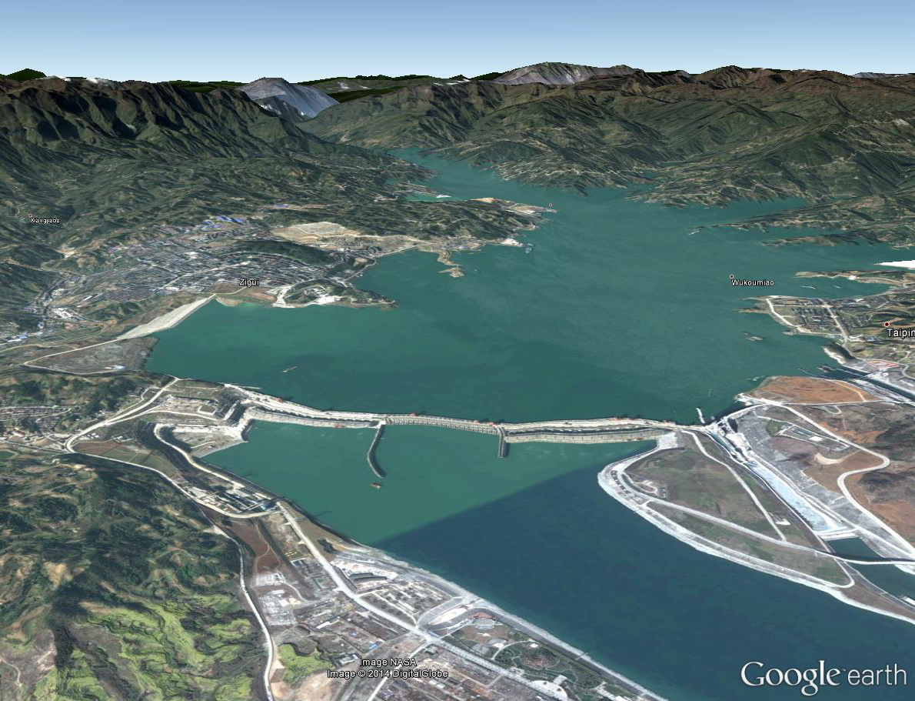
Figure 1. 3D view of the Three Gorges Dam (China), the Yangtze River valley and steep slopes [©2016 DigitalGlobe, GoogleEarth].

The study will focus on the Three Gorges in China, located in the middle reach of the Yangtze River, the third longest river in the world. Landslides represent a major hazard in the Three Gorges region due to the extremely steep slopes on the gorges and erosion of riverbanks. Furthermore, the Three Gorges Dam Project has recently increased landslide hazards in this region due to the change of water table following the impoundment from the Dam as the water level rose up to 175 metres above sea level in 2010.

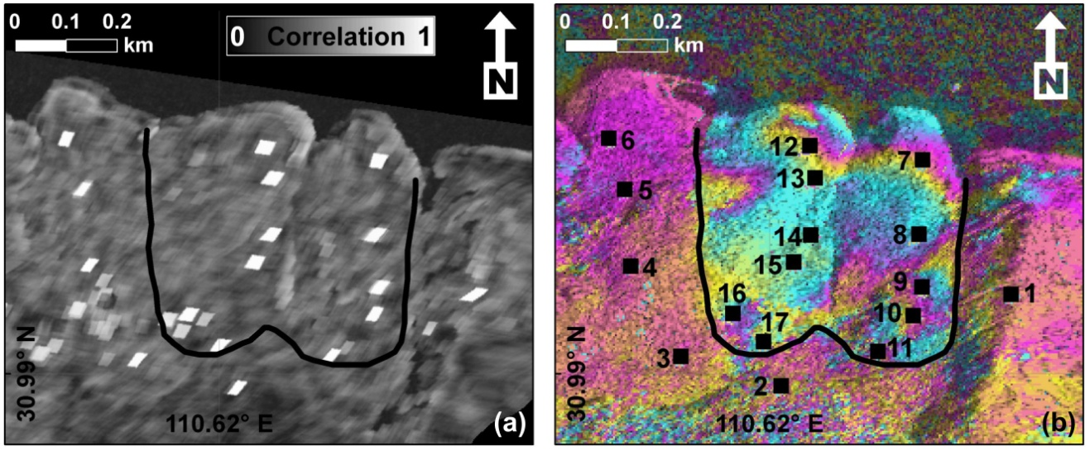
Figure 2. The Shuping landslide in the Three Gorges, China: (a) TerraSAR-X Spotlight correlation (21st Feb – 4th Mar 2009). (b) TerraSAR-X interferogram showing the landslide boundary (9th– 20th May 2009) [Singleton et al., 2014]. Note: White areas in (a) and black squares in (b) represent corner reflectors.

A wealth of satellite radar data, including X-band TerraSAR-X, C-band Envisat and Sentinel-1, and L-band ALOS and ALOS-2 has been collected in this region and archived by the German, European and Japanese Space Agencies, thus creating a rich and densely populated data reservoir of historical information on this dynamic region. Special arrangements are also in place to access ground observations and other geodetic monitoring and topographic data (e.g. Ku-band FastGBSAR, GNSS and Laser Scanning) to integrate satellite information and for validation purposes.

Methodology

The PhD student will first exploit conventional Interferometric SAR (InSAR) to detect active landslides at the regional scale. Analysis of the performances of L-, S-, C- and X-band data with respect to surface motion velocity, local topography and land cover (e.g. presence of dense vegetation) will be undertaken, building upon the methodological approach developed at the British Geological Survey [Cigna et al., 2014]. InSAR time series (e.g. Persistent Scatterer and Small Baseline InSAR) will be utilised at the local scale to monitor extremely slow landslides affecting the steep slopes of the gorges, whilst the SAR Pixel Offset Time-series (SPOT) technique will be employed to monitor the development of fast-moving landslides [Singleton et al. 2014]. FastGBSAR, GNSS and Terrestrial Laser Scanning (TLS) will further illustrate details of the spatial and temporal distributions of landslide motion. In situ measurements of rainfall, river water level, and water pressure in the sub-surface will allow the PhD student to directly relate these parameters to the resulting landslide deformation [Tomás et al. 2015]. Results from the detailed geodetic imaging of landslide deformation will improve the understanding of how landslides mobilize in response to changing environmental and hydrological conditions [Tomás et al. 2014].
To investigate the destructive impacts of landslides that occur in a reservoir, an in-house hydrodynamic model developed at Newcastle University [Smith and Liang, 2013; Amouzgar et al. 2014] will be used to simulate the propagation of the surface waves generated by a landslide and their interaction with the Three Gorges Dam followed by an assessment of dam safety.

Timeline

Year 1: Training in space geodesy and remote sensing techniques, in particular the handling of satellite and ground-based radar data, with the aim of detecting and monitoring active landslides in the study sites. In parallel, training will be provided on the mechanics of landslides.

Year 2: The time series of surface displacement maps will be built using the available multi-wavelength satellite radar data, and the impacts of environmental/geotechnical parameters on landslide motion will be assessed. Field work in the Three Gorges region will be carried out to collect field evidence and acquire FastGBSAR, GNSS and TLS measurements, and validate satellite observations. It is envisioned that the combined work of Years 1 and 2 should lead to at least one published output.

Year 3: Modelling surface displacement time series to understand the mechanisms of landslides and simulating landslide induced wave propagation and interaction with the Three Gorges Dam. This should lead to the second and third publications, and presentation at international conferences (e.g. AGU Fall Meeting in San Francisco, USA).

Year 4: The final year of the studentship will be focussed on combining the published outputs and associated material into the PhD thesis. The summary of landslide hazards in the Three Gorges region may lead to the fourth publication.

Training & Skills

The student will receive training in space geodesy and remote sensing techniques, in particular the handling of satellite radar and GPS data, and in modelling the mechanics of landslides. Training in a wide range of generic skills (e.g. presentation skills, paper/thesis writing, and enterprise skills) to prepare the student for life as a PhD student and afterwards is provided by the Faculty of Science, Agriculture and Engineering at Newcastle via the Postgraduate Researcher Development Programme (PGRDP). Whilst the PhD studentship will be based at Newcastle, the project will include periods at the British Geological Survey (BGS) in Keyworth, to receive training on scientific and technical skills (e.g. Engineering Geology, ArcGIS, 3D visualisation) and work in the Remote Sensing Laboratory with GIS and radar processing specialist software. The student will also benefit from cross-disciplinary training provided as part of IAPETUS across the partner organisations.
The student will also participate in the activities of the Centre for the Observation and Modelling of Earthquakes, Volcanoes and Tectonics (COMET) and thus benefit from the shared expertise of Geosciences staff in several universities across the country, attending also regular workshops where cutting-edge research of COMET scientists is presented and discussed.
The student will also have opportunities to work with other partners in the UK and internationally and they are encouraged to travel to national and international scientific conferences and workshops to present results. We aim to see all students publish 3-4 papers in leading scientific journals during their PhD. Upon completion, the student will be well equipped for a career in academia or in a range of industries.

References & Further Reading

Amouzgar, R, Liang, Q, Smith, L. A GPU-accelerated shallow flow model for tsunami simulations. Proceedings of the Institution of Civil Engineers - Engineering and Computational Mechanics 2014, 167(3), 117-125.

Cigna, F, Bateson, L, Jordan, C and Dashwood, C. Simulating SAR geometric distortions and predicting Persistent Scatterer densities for ERS-1/2 and ENVISAT C-band SAR and InSAR applications: Nationwide feasibility assessment to monitor the landmass of Great Britain with SAR imagery. Remote Sensing of Environment 2014, 152, 441-466.

Petley, 2014. The landslide blog, http://blogs.agu.org/landslideblog

Dai, K., Li, Z., Tomás, R., Liu, G., Yu, B., Wang, X., Cheng, H., Chen, J. & Stockamp, J. Monitoring activity at the Daguangbao mega-landslide (China) using Sentinel-1 TOPS time series interferometry, Remote Sensing of Environment 2016, 186, 501-513.

Singleton, A, Li, Z, Hoey, T, Muller, J-P. Evaluating sub-pixel offset techniques as an alternative to D-InSAR for monitoring episodic landslide movements in vegetated terrain. Remote Sensing of Environment 2014, 147, 133-144.

Smith, LS, Liang, Q. Towards a generalised GPU/CPU shallow-flow modelling tool. Computers & Fluids 2013, 88, 334–343.

Tomás, R, Li Z, Liu, P, Singleton, A, Hoey, T, Cheng, X. Spatiotemporal characteristics of the Huangtupo landslide in the Three Gorges region (China) constrained by radar interferometry. Geophysical Journal International 2014, 1-20.

Tomás, R, Li, Z, Lopez-Sanchez, JM, Liu, P, & Singleton, A. Using wavelet tools to analyse seasonal variations from InSAR time-series data: a case study of the Huangtupo landslide. Landslides, 2015, 1-14.

Further Information

Professor Zhenhong Li

Zhenhong.Li@newcastle.ac.uk, 0191 208 5704
http://www.ncl.ac.uk/ceg/role/profile/zhenhongli.html

Dr Francesca Cigna
fcigna@bgs.ac.uk, 0115 936 3551
http://www.bgs.ac.uk/staff/profiles/40651.html

Professor Qiuhua Liang

Qiuhua.Liang@ncl.ac.uk, 0191 208 6413
http://www.ncl.ac.uk/ceg/role/profile/qiuhualiang.html

Annex 1 // Additional Administrative Information

Principal Disciplinary Theme (s)  Tick the relevant box(s). | ☐ Global Environmental Change  ☐ Geodynamics & Earth Resources  ☐ Carbon & Nutrient Cycling  ☒ Hazards, Risk & Resilience  ☐ Biodiversity & Ecosystem Resources

Total of Amount of RTSG Requested: | £ 8000
Justification for RTSG Request:
We request £3000 to cover conference and workshop attendance (1 AGU Fall Meeting and 1 ESA FRINGE).
We request £2000 to purchase newly acquired TerraSAR-X (and/or COSMO-SkyMED) images.
We request £3000 to support field work in the Three Gorges region (£1500 per trip for two field trips).

CASE Partner Contributions & Other Relevant Information:
n/a
Where possible, a letter of support from the named CASE Partner should be provided to IAPETUS.

If part of an Integrated Studentship Network (ISN), please list the linked projects (title and principal supervisor):
n/a

Any other relevant information:
n/a

